Jacket Pride T-Shirt Order Form
(These are the Navy shirts with “Lee County High School March Yellow Jackets“ on the left front and “The Pride of Lee County“ on the back. All writing is in gold). Sweatpants will be same colors with design down the leg.
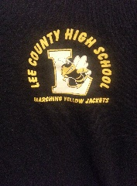
Student Name: ______________________________________________________
Contact #:__________________________________________________________
Email: ______________________________________________________________
Short Sleeved T-Shirt
________Small($10) ________Medium($10) ________Large($10) _______X-large($10)
________XX-Large ($12) ________XXX-Large($12)
Long Sleeved T-Shirt
________ Small($12) ________Medium($12) ________Large($12) _______X-large($12)
________XX-Large ($15) ________XXX-Large($15)
Sweat Shirt
________ Small($15) ________Medium($15) ________Large($15) _______X-large($15)
________XX-Large ($18) ________XXX-Large($18)
Hoodies
________ Small($20) ________Medium($20) ________Large($20) _______X-large($20)
________XX-Large ($23) ________XXX-Large($23)
Sweat Pants- elastic at ankles, no pockets
________ Small($15) ________Medium($15) ________Large($15) _______X-large($15)
________XX-Large ($18) ________XXX-Large($18)
Total number of items: __________ Total Money included_________________
All orders must be turned in no later than Friday August 4, 2017 (End of first week of band camp)
Checks made payable to: Lee County Band Boosters

